**Online Education Employment Project (Website)**

**Prototype Report**

VEL Team

Date: 15/SEP/2015

Document Modification History/Revision log

|  |  |  |  |
| --- | --- | --- | --- |
| Version | Date | Author | Description of Change |
| 1.0 | 10/09/2015 | Miranda, Irene | Initial version |
| 2.0 | 15/09/2015 | Irene | Finished detail parts of the reports |
| 3.0 | 15/09/2015 | Kaii | Add Scrum Management and Mobile Friendly test |
| 4.0 | 15/09/2015 | VEL Team | Add individual Retrospective |
|  |  |  |  |

Contents

**Project Description: 1**

**Delivered Software Increment 1**

**Completed Product Backlog 2**

**Sprint Backlog 4**

**Prototype Details 7**

**NUnit Tests 16**

**Mobile Friendly Test (Google) 16**

**Scrum Management 17**

**Sprint Review 19**

**Retrospective 20**

**Group Evaluation: 21**

Project Description:

The goal of this project is to create an adaptive (mobile friendly) website to help IT students and unemployed people to get useful skills. The home page should draw visitors’ attention so that they would like to register as fixed users. And users can choose the courses they want to take according to some success stories. We use the .NET Framework and the Visual Studio development environment to develop the website.

|  |  |  |  |  |
| --- | --- | --- | --- | --- |
| *No.* | *GitHub username* | *SeeNowDo* | *Official name* | *UPI* |
| *1* | gaoyiqun | Irene | Yiqun Gao | YGAO742 |
| *2* | huajinxie | Kaii | Huajin Xie | HXIE519 |
| *3* | likaihe | Likai | Likai He | LHE838 |
| *4* | lulujing | LuLu | Jing Lu | JLU986 |
| *5* | vasanthnewzealand | V | Vasanth Boraiyan | VBOR051 |
| *6* | yazang | Clay | Chen Yang | CYAN988 |
| *7* | yinqi522 | Miranda | Yu Guo | YGUO425 |
| *8* | YsqEvilmax | Shawn | Shaoqing Yu | SYU702 |

Delivered Software Increment

Our team have finished 6 user stories in the product backlog in the past Sprint. The prototype is a website include Login function, Admin function, homepages, Success story list pages and detail pages. This website use a 3 tier architecture. Communication and data exchange between the 3 layers can be easily achieved with Model-View-Controller (MVC 5) patterns. The presentation layer, business logic layer and database layer, can be easily developed and maintained separately by using MVC 5. We’ve also redesigned Database, to ensure that no conflict in the DB integration.

Currently completed pages and functions in the prototype can be tracked through two flows – Admin flow and Visitor flow:

From the Admin Flow: Homepages 🡪 Login page (Admin) 🡪 Success Story List Admin Pages 🡪 Success Story Detail Admin pages 🡪 Success Story Detail Admin Pages (Add/Edit/Delete) 🡪 Success Story List Admin Pages

Form the Visitor Flow:

1. Homepages 🡪 Success Story List Pages 🡪 Success Story Detail Pages
2. Homepages 🡪 Team Profile Pages 🡪 FAQs Pages

Completed Product Backlog

|  |  |  |  |
| --- | --- | --- | --- |
| **No.** | **Completed User Stories** |  | **Relative tasks** |
| 1. | As CEO,  I would like to re-design our website (first page) to make it mobile friendly. | So that we can meet ranking requirement, because Google adopted mobile-friendliness as a ranking signal. | (Home Pages) |
| 2. | As a VISITOR (anonymous user),  I would like to read some success stories of previous students and select the same courses. | So that I can follow the same approach and select suitable courses accordingly. | (Success stories List Pages) |
| 3. | As a VISITOR (anonymous user),  I would like to read the detail of some success story and get to know what courses they’ve learned. | So that I can order the same courses. | (Success stories detail pages) |
| 4. | As CEO,  I would like our team profile and FAQ to be well noticed. | So that we can provide more detail information about our company. | (Team Profile & FAQs Page) |
| 5. | As an ADMIN (course advisor),  I would like to maintain success stories with Add, Update, and Delete. | So I can update and maintain the story pages. | (Admin functions of success story pages included add, edit, delete pages) |
| 6. | As a USER,  I would like to login to my category (Admin or Students) in the system. | So I can maintain or learn on the website. | (Login Pages) |

Sprint Backlog

|  |  |  |  |  |  |  |
| --- | --- | --- | --- | --- | --- | --- |
| Story  ID | User Story | Task  ID | Task | Owner &  Participant | UPI | Hours |
| 1 | Home Page | 31 | Home Draft | ClayY | CYAN988 | 8.0 |
|  |  | 32 | Home Page Update (after review) | ClayY | CYAN988 | 2.0 |
|  |  | 32 | Home Page Update (after review) | Irene | YGAO742 | 6.0 |
|  |  | 33 | Test Case (HP) | Irene | YGAO742 | 1.0 |
|  |  | 34 | Unit Test (HP) | Irene | YGAO742 | 1.0 |
| 2 | Success Story List | 41 | Story List (staic) | LikaiH | LHE838 | 10.0 |
|  |  | 42 | Story List (dynamic) | ClayY | CYAN988 | 8.0 |
|  |  | 43 | Test Case (Story List) | Lulu | JLU986 | 4.0 |
|  |  | 44 | Unit Test (Story List) | Irene | YGAO742 | 1.0 |
| 3 | Success Story Detail | 45 | Detail Success Story Page | ClayY | CYAN988 | 4.0 |
|  |  | 46 | Test Case (Story Detail) | Miranda | YGUO425 | 3.0 |
|  |  | 47 | Unit Test (Story Detail) | Miranda | YGUO425 | 2.0 |
| 4 | Team Profile & FAQ | 48 | Team profile page | ClayY | CYAN988 | 2.0 |
|  |  | 49 | FAQ page | LikaiH | LHE838 | 2.0 |
| 5 | Admin of Success Story | 51 | Admin (List page) | Kaii | HXIE519 | 9.0 |
|  |  | 52 | Admin (Edit page) | Kaii | HXIE519 | 8.0 |
|  |  | 53 | Admin (Add page) | V | VBOR051 | 7.0 |
|  |  | 53 | Admin (Add page) | Kaii | HXIE519 | 1.0 |
|  |  | 54 | Test Case & NUnit (Add) | Miranda | YGUO425 | 4.0 |
|  |  | 55 | Test Case & NUnit (Edit) | Miranda | YGUO425 | 4.0 |
|  |  | 56 | Test Case & NUnit (List) | Lulu | JLU986 | 4.0 |
|  |  | 57 | Unit Test (Story Detail) | Lulu | JLU986 | 3.0 |
|  |  | 58 | Admin (Delete page) | Kaii | HXIE519 | 3.0 |
| 6 | Login Page | 61 | Login Page | Miranda | YGUO425 | 6.0 |
|  |  | 62 | Test Case & Nunit (Login) | Irene | YGAO742 | 4.0 |
|  |  | 63 | Unit Test (Login) | Irene | YGAO742 | 1.0 |
| x1 | Developing Enviroment | 11 | Collect DB Design and PHP programs | V | VBOR051 | 2.0 |
|  |  | 12 | Create New DB | V | VBOR051 | 2.0 |
|  |  | 12 | Create New DB | Miranda | YGUO425 | 1.0 |
|  |  | 13 | Prepare dummy Data | V | VBOR051 | 1.0 |
|  |  | 13 | Prepare dummy Data | Miranda | YGUO425 | 3.0 |
|  |  | 21 | Create .Net solution | Shawn | SYU702 | 4.0 |
|  |  | 22 | Create header & Footer template | Shawn | SYU702 | 6.0 |
|  |  | 23 | Create base page | Shawn | SYU702 | 15.0 |
| x2 | Scrum Activities | 01 | Client Meeting(25/08/2015) | ALL members |  | 4.0 |
|  |  | 02 | Scrum board init | Kaii | HXIE519 | 1.0 |
|  |  | 03 | Draft tasks list | Kaii | HXIE519 | 1.0 |
|  |  | 91 | Daily Scrum (28/08/2015) | ALL members |  | 1.0 |
|  |  | 92 | Daily Scrum (02/09/2015) | ALL members |  | 1.0 |
|  |  | 93 | Daily Scrum (05/09/2015) | ALL members |  | 1.0 |
|  |  | 94 | Daily Scrum (08/09/2015) | ALL members |  | 1.0 |
|  |  | 95 | Daily Scrum (11/09/2015) | ALL members |  | 1.0 |
|  |  | 96 | Retrospective Meeting | ALL members |  | 4.0 |
|  |  | 97 | Client review Meeting(14/09/2015) | ALL members |  | 6.0 |
|  |  | 98 | Client review Meeting(14/09/2015) | ALL members |  | 2.0 |

Prototype Details

1. User Story 1: New Designed Mobile Friendly Home Pages – PC View and Phone View

URL: <http://getskills.azurewebsites.net/>

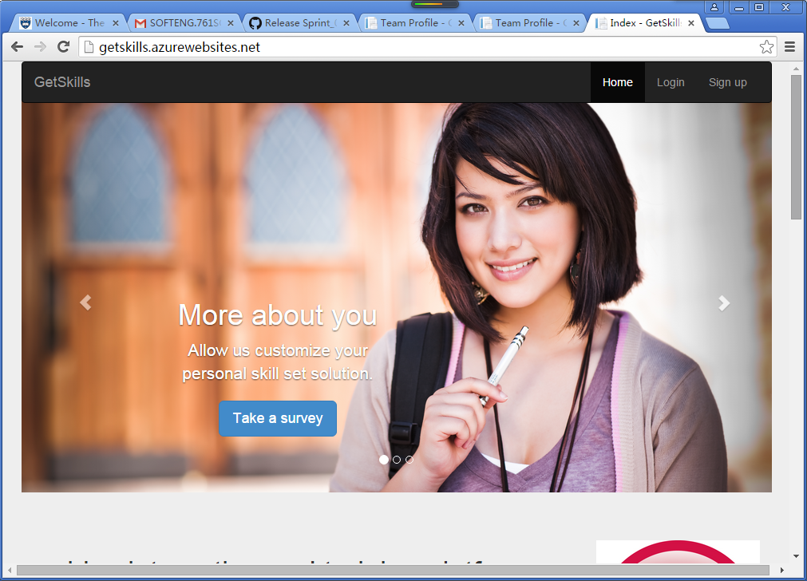

1. User Story 2: As a VISITOR (anonymous user), I would like to read some success stories of previous students.

** At the bottom of the Home Page (<http://getskills.azurewebsites.net/>), there is a link – “Success Stories” located in “Site Map” zone.

URL: <http://getskills.azurewebsites.net/SuccessStory/List>

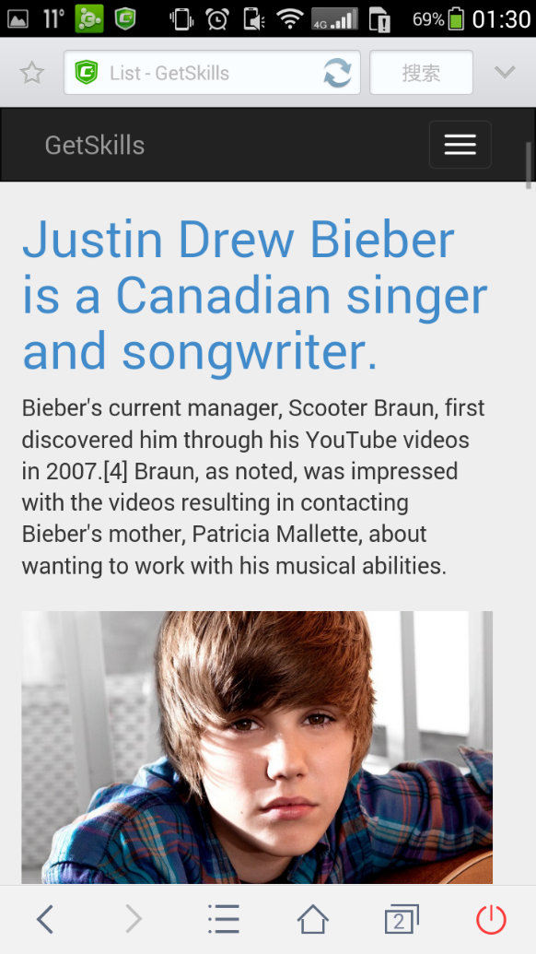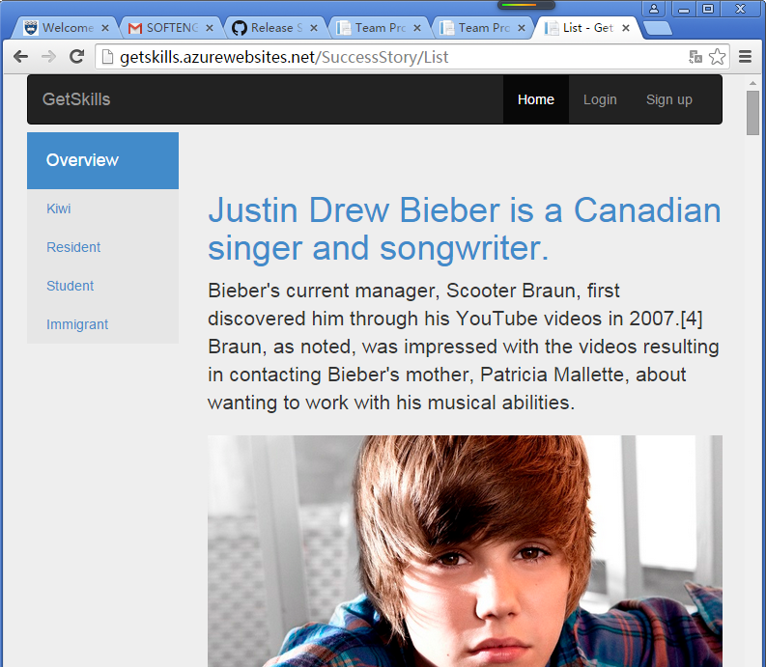

1. User Story 3: As a VISITOR (anonymous user), I would like to read the details of some success stories.

** Click the title of each success story in Success Stories List Page (<http://getskills.azurewebsites.net/SuccessStory/List>), the pages will navigate to the relative Success Story Detail Pages. Visitors can jump back to the Success Stories List Pages by clicking ‘Back to list’ link at bottom.

URL: For example: <http://getskills.azurewebsites.net/SuccessStory/Detail/2>, or <http://getskills.azurewebsites.net/SuccessStory/Detail/1>

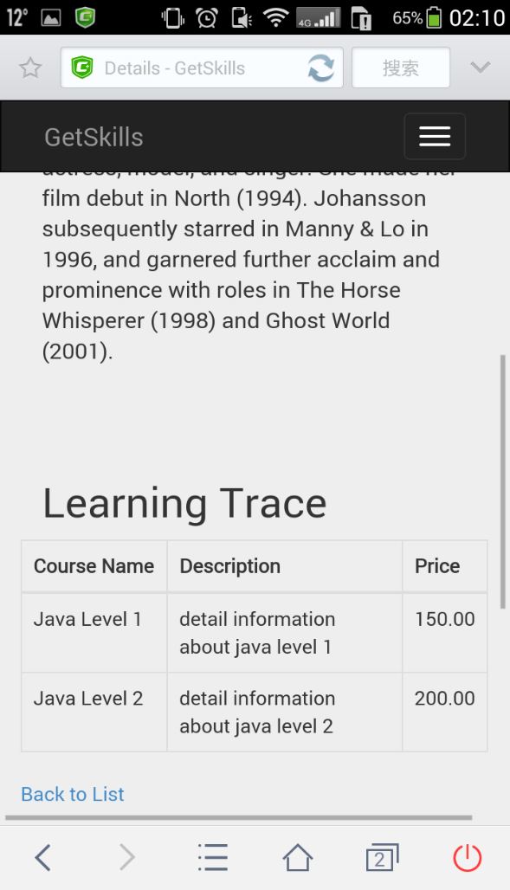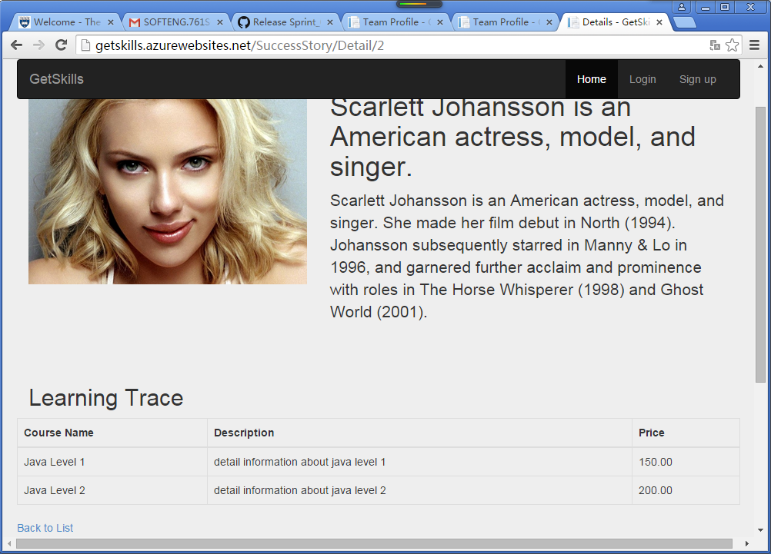

1. User Story 4: As CEO, I would like our team profile and FAQ to be well noticed.

** At the bottom of the Home Page (<http://getskills.azurewebsites.net/>), the ‘Team Profile’ link will lead visitors to the Team Profile Pages

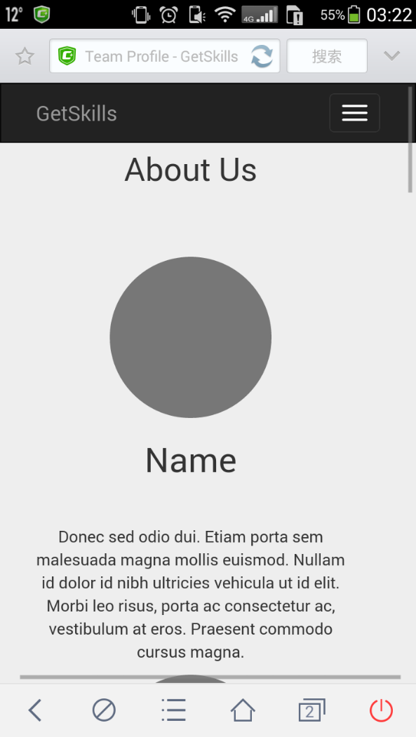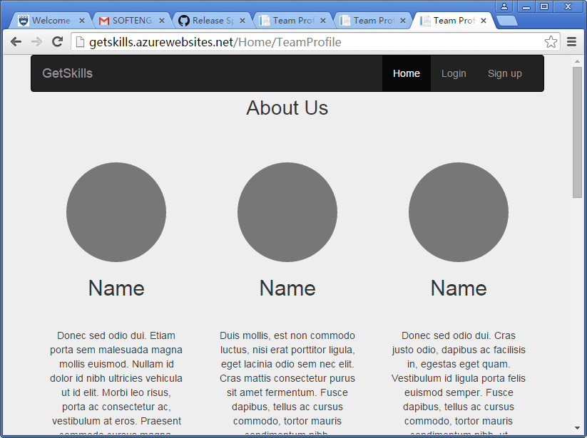URL: <http://getskills.azurewebsites.net/Home/TeamProfile>

** At the bottom of the Home Page (<http://getskills.azurewebsites.net/>), the ‘Team Profile’ link will lead visitors to the Team Profile Pages

URL: <http://getskills.azurewebsites.net/Home/FAQ>

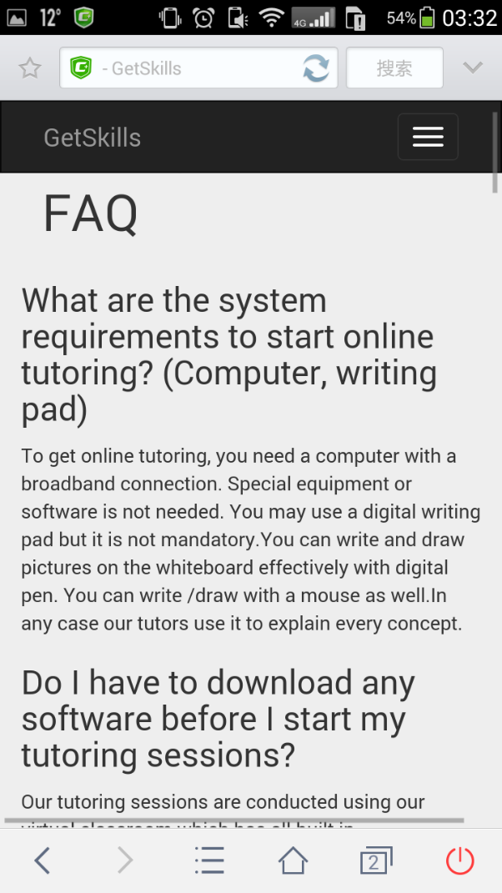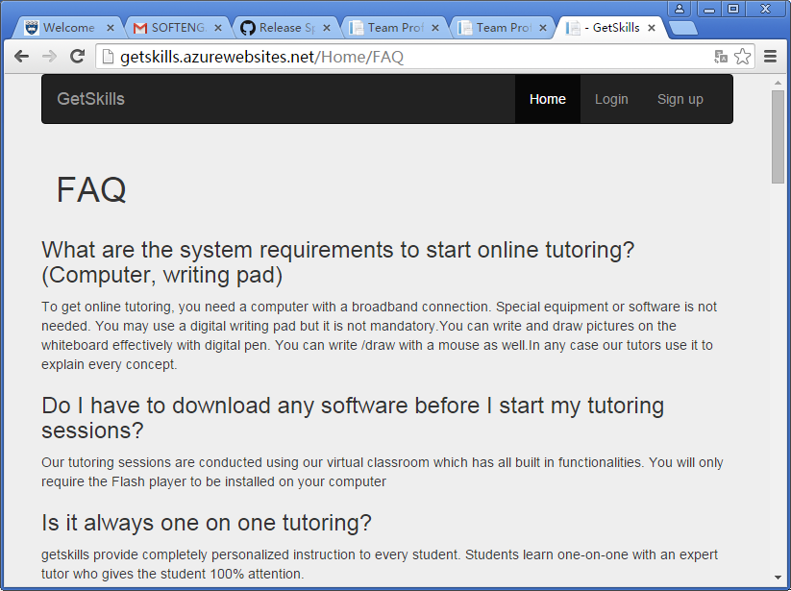

1. User Story 5: As an ADMIN (course advisor), I would like to maintain success stories with Add, Update, and Delete.

** For ADMIN functions, Product Owner informed us that they won’t maintain the stories by using mobile phones. So that we only developed the PC pages.

** Based on security considerations, we decided not to show the ‘Admin Login’ link on public website pages. Administrators can login to ADMIN pages through the link – <http://getskills.azurewebsites.net/Account/AdminLogin>

(UserName: aaaa Password: 123456)

1. Admin URL: <http://getskills.azurewebsites.net/SuccessStory?sortOrder=ID_asc>

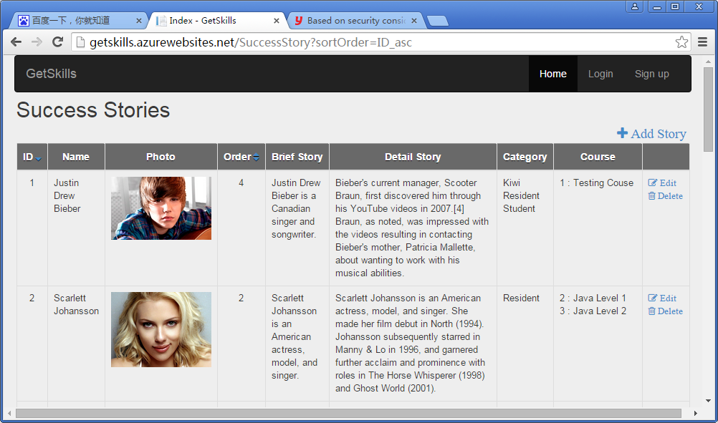

1. By click the “+ Add Story” on Admin pages, administrators can create new success stories.

URL: <http://getskills.azurewebsites.net/SuccessStory/Create>

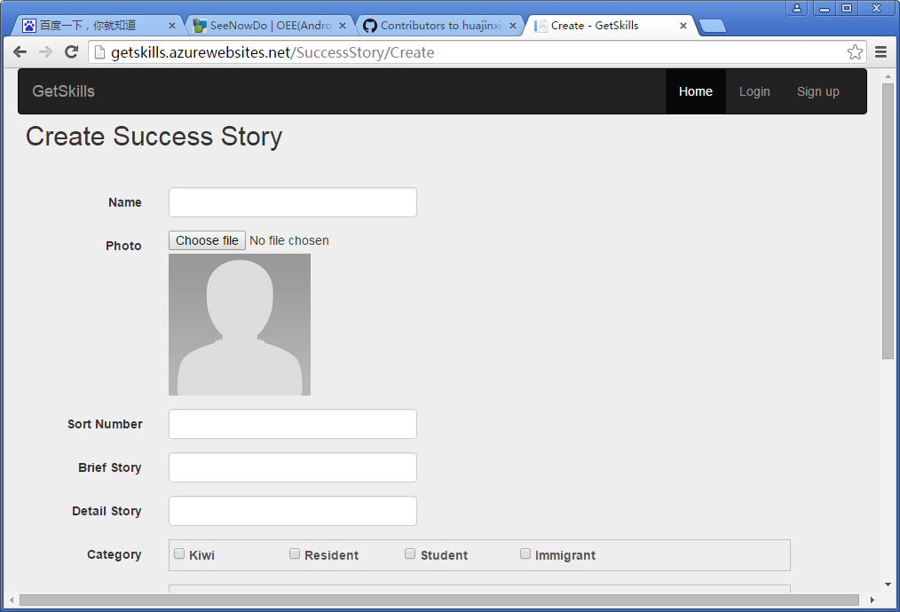

1. By click the “Edit” button after each success stories on Admin pages, administrators can edit exist success stories.

URL: <http://getskills.azurewebsites.net/SuccessStory/Edit/1>

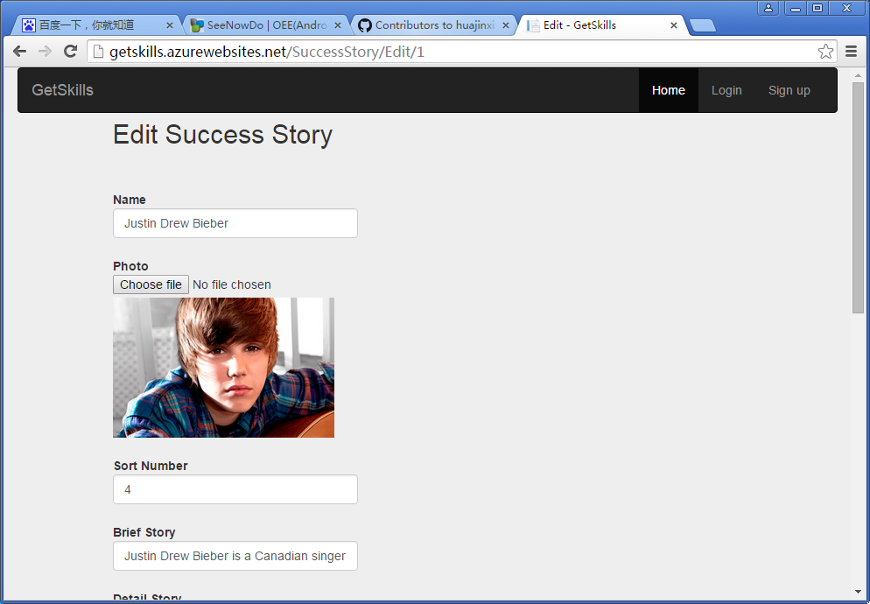

1. By click the “Delete” button after each success stories on Admin pages, administrators can delete exist success stories.

URL: <http://getskills.azurewebsites.net/SuccessStory/Delete/4>

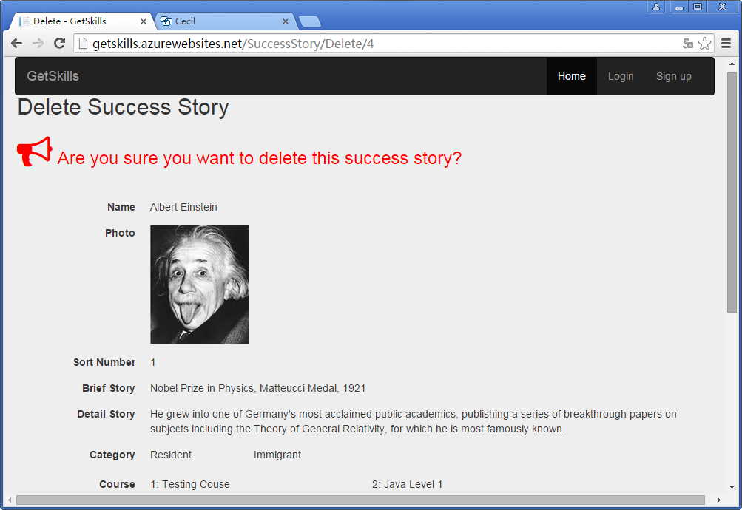

1. User Story 6: As a USER, I would like to login to my category (Admin or Students) in the system.

** No matter which pages visitors are surfing, they can always login/Register in the website by click the related links on heater (Navbar). They can also choose to login by using Google Accounts or Facebook Accounts.

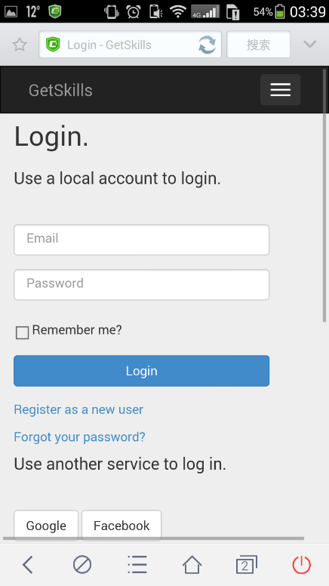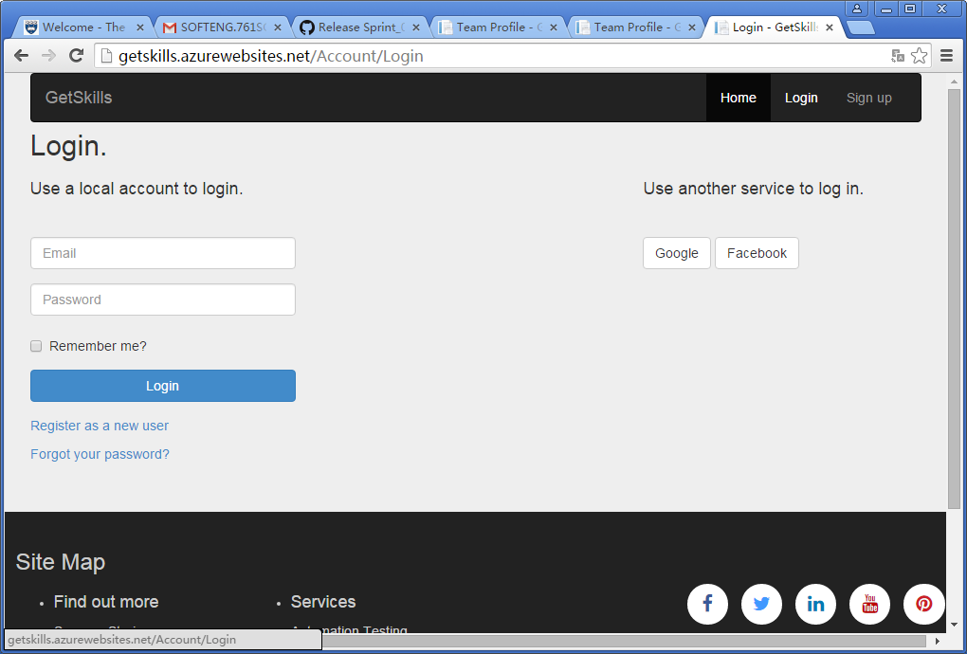URL: <http://getskills.azurewebsites.net/Account/Login>

.

NUnit Tests

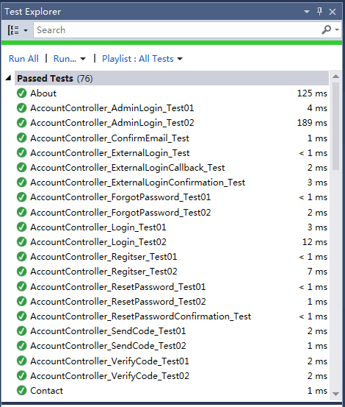We mainly use Nunit, which is an open source unit testing framework for Microsoft .Net, in completing the test cases and Unit tests processes.

In our project, Unit testing for Web Page are implemented. And NUnit testing are implemented for all Controller Classes and methods. Our tests also including sync unit tests.

The methods in controllers have been tested as more as possible. The source codes have passed all of the 76 test cases.

Mobile Friendly Test (Google)

• Test result of old system: Un-friendly • Test result of new system: Mobile friendly

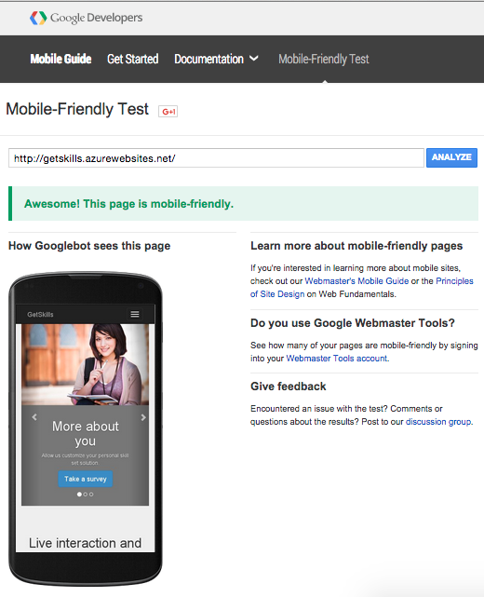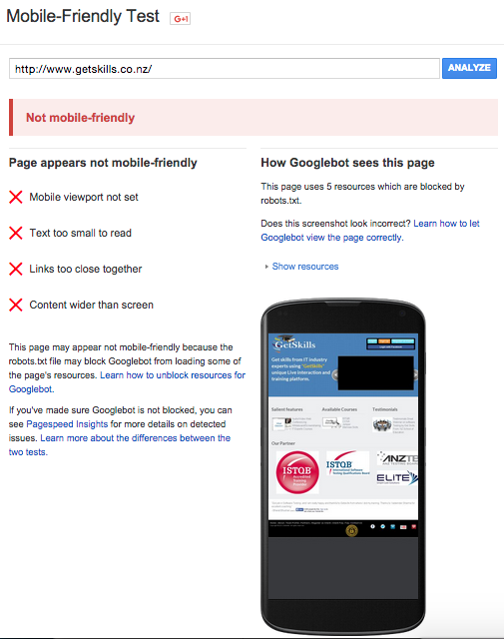

Scrum Management

We use SeeNowDo (URL: [https://www.**seenowdo**.com/](https://www.seenowdo.com/)) as our Scrum management tool.

* Main board

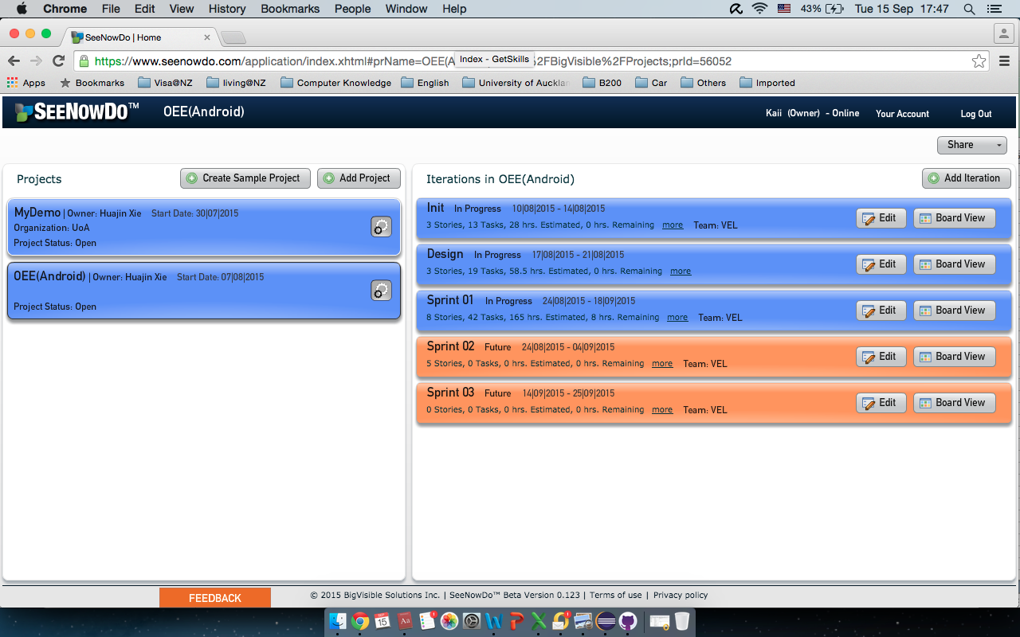

* Scrum Board (Sprint 01)

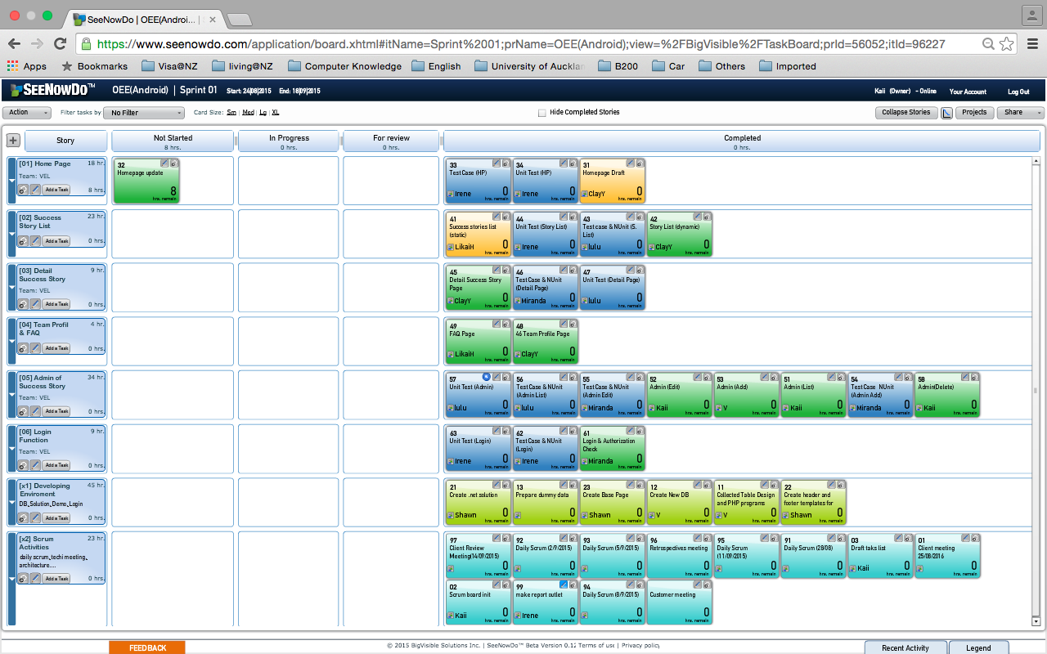

* Burn-down chart (By hours)

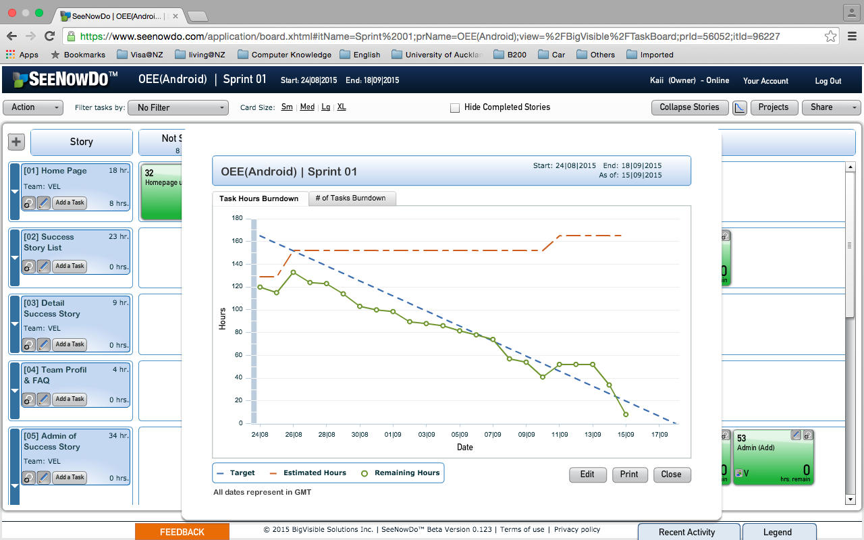

* Burn-down chart (By tasks)

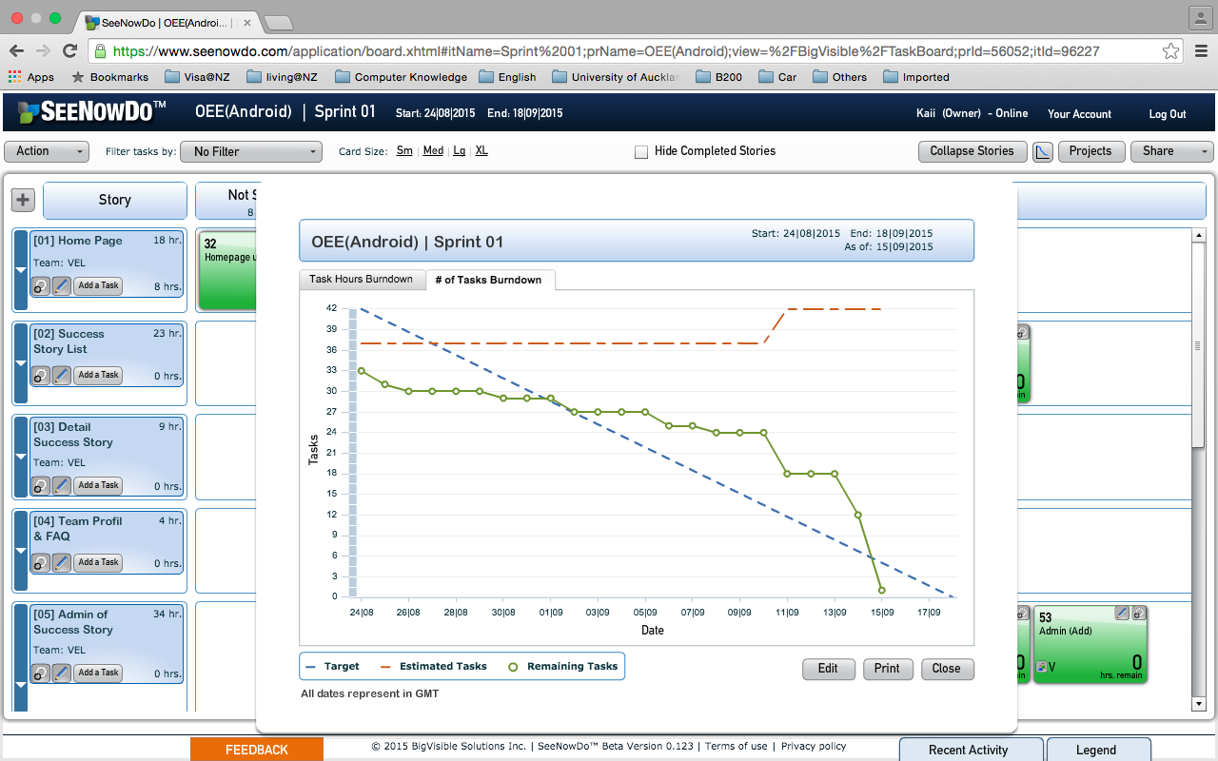

Sprint Review

Our team had a Sprint Review meeting with the attendances of Scrum Master, team members and Product Owner–Yadwinder on September 14th. We’ve displayed our prototype to client. We’ve get positive feedbacks on most of our efforts for the project.

Product Owner–Yadwinder inspected the project and give us four suggestions in adapting the Prototype.

1. Team Profile pages need to be more colourful and interactive.

Add LinkedIn profile links of each members on Team Profile pages.

Design and provide Admin Pages for Team Profiles in next Sprint.

1. Shift “contact us” link form the footer to Navbar (Heater).
2. Adjust the pictures and ISTQB logos in Home Pages.
3. Add “share to social media (Twitter/Facebook) function” on Success Story List Pages and Success Story Detail Pages.

According to PO’s suggestions, we will adjust our project by the end of this Sprint on September 18th Fri.

Retrospective

Group Evaluation:

In general, our group did a good job for the first sprint. We defined a reasonable sprint backlog and followed SCRUM process strictly. Everyone got one task at first and after finished it he/she could get another task. We held stand-up meetings regularly so that we could know each other’s progress and obstacles. If anyone had a problem, others would help him/her. Some of us did not have programming experience before, so their progress might be slow. But everyone tried to finish the tasks as soon as possible and make the project perfect. Besides, every scrum master communicated with our customer as much as possible to ensure that the project could meet the demands.